* **Strict Mode** is used to allow you to place a program, or a function, in a “strict” operating context.
* **Strict Mode** saves time having syntax or semantics errors such as using variable without pre-defining it, or using reserved words as names for the variable.
* **Strict Mode** is used by writing“use strict” in global scope for the entire program, classes, or individual functions.
* Using var to define a variable causes many errors, so using strict mode solves these problems. In some cases, if JavaScript finds a variable that is not defined before it applies hoisting which defines it above these lines. In some cases this is not true.

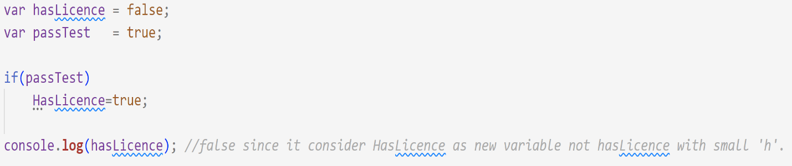

* **Strict Mode** is nested which means any defined variable or function in the scope of “use strict” will be also strict.

